

ISTANBUL TECHNICAL UNIVERSITY

DEPT. OF MECHANICAL ENGINEERING

MKM506E | Modelling & Control of Mechanical Systems

**Final Exam**

Lecturer: Prof. Dr. Ata Muğan

**Abdurrahim Bilal ÖZCAN**

**514191026**

28 June 2020 | ISTANBUL

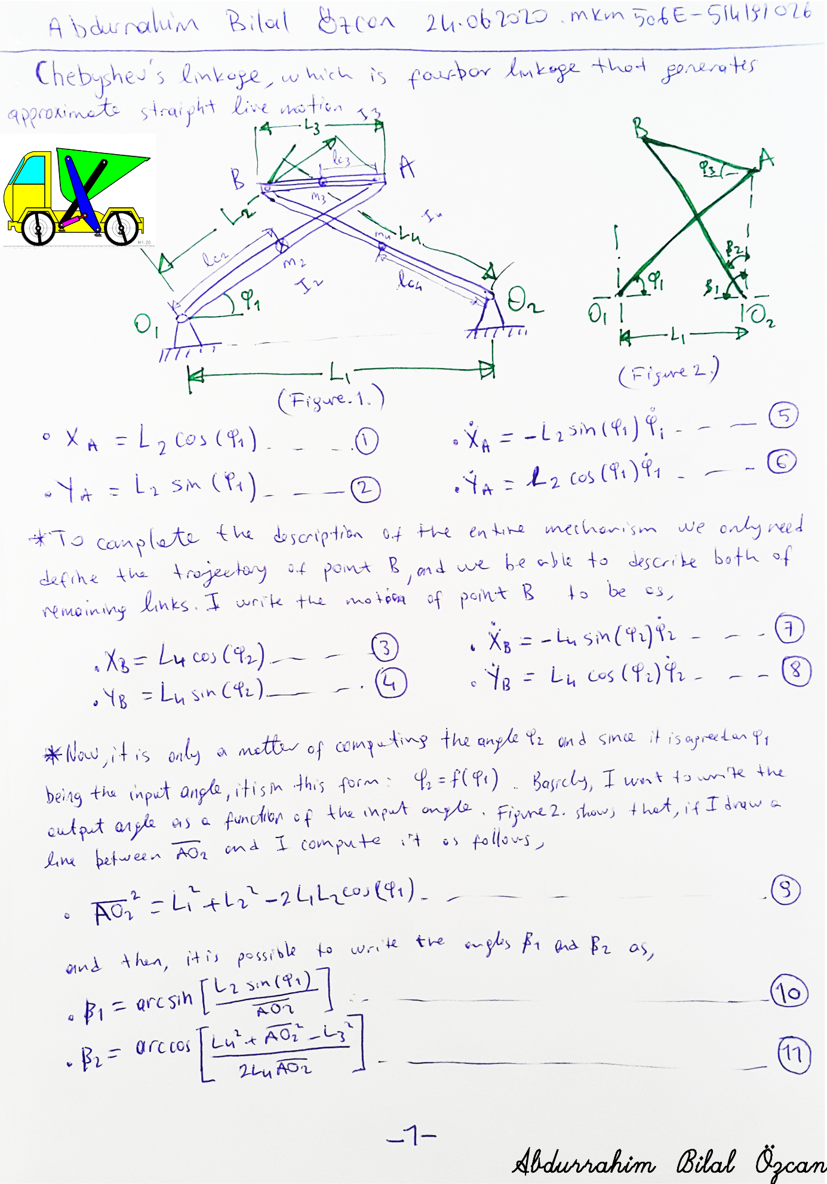

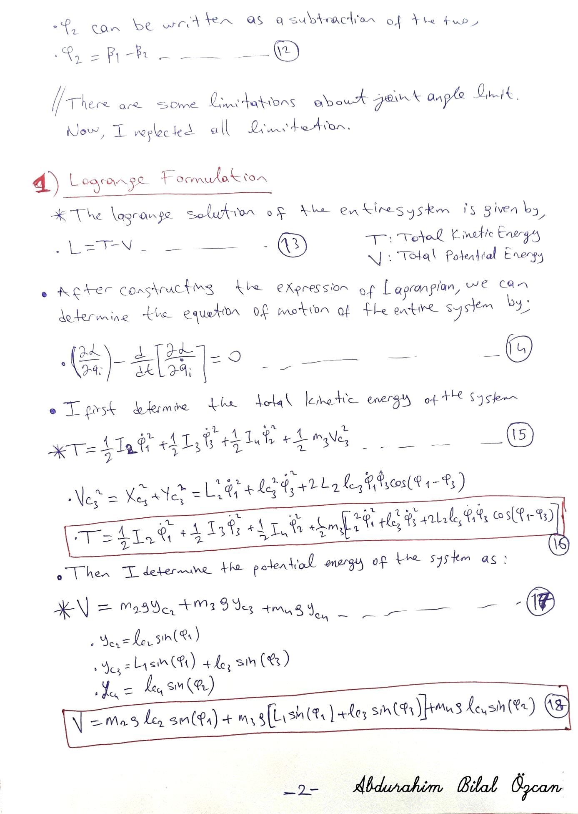

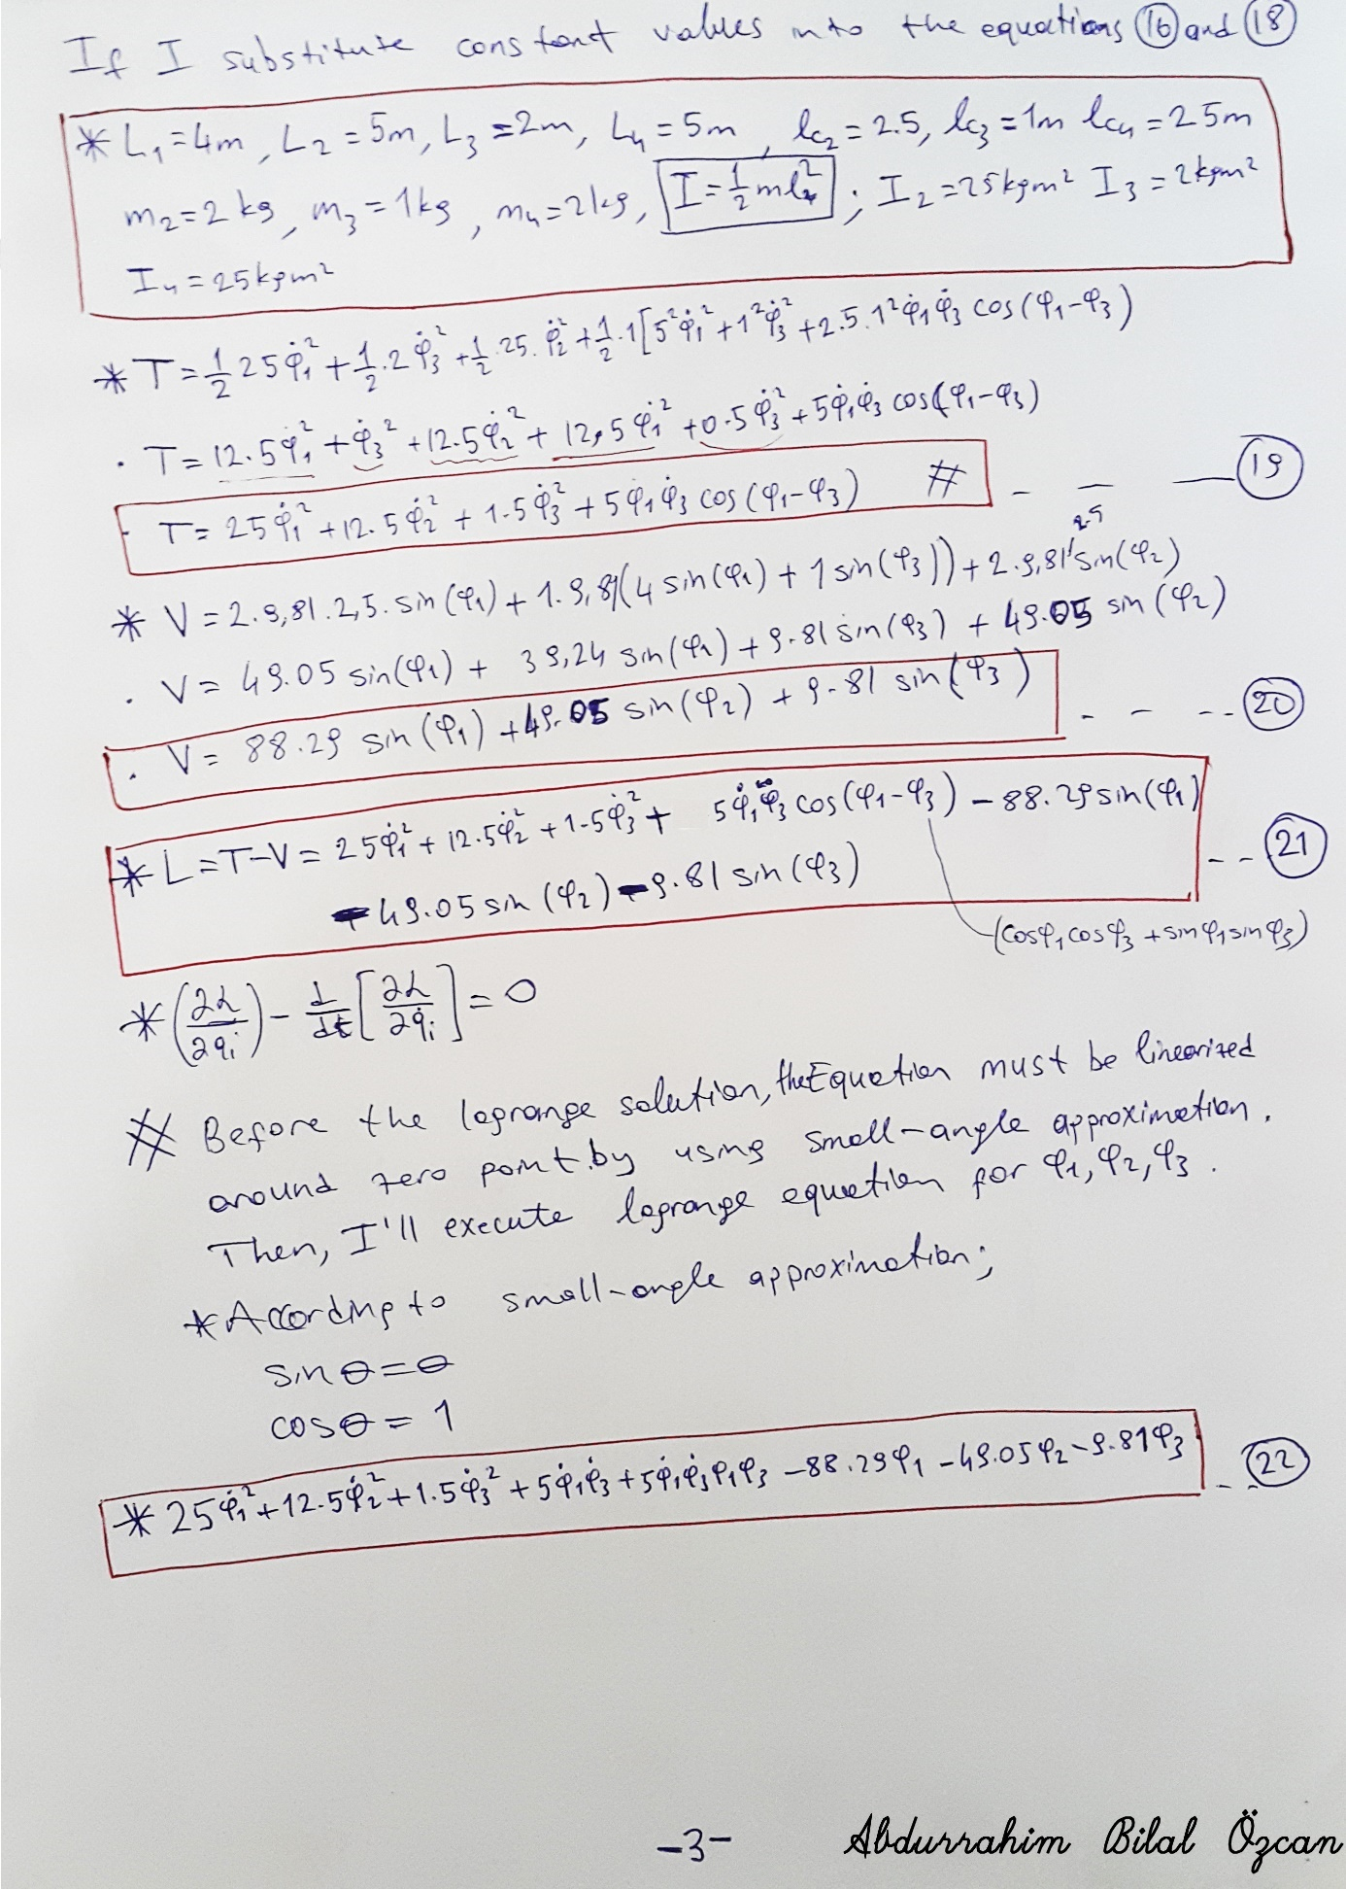

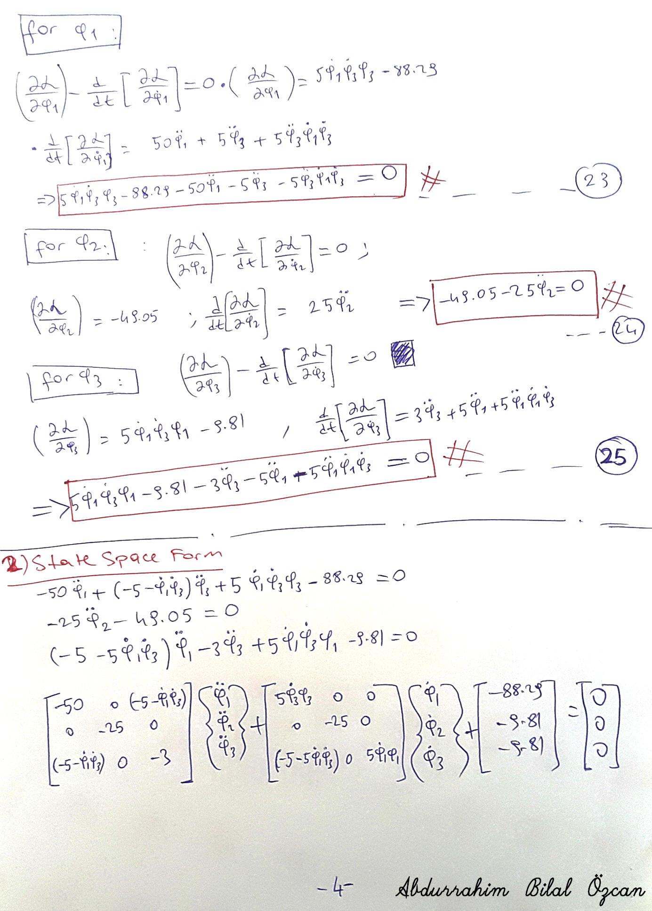

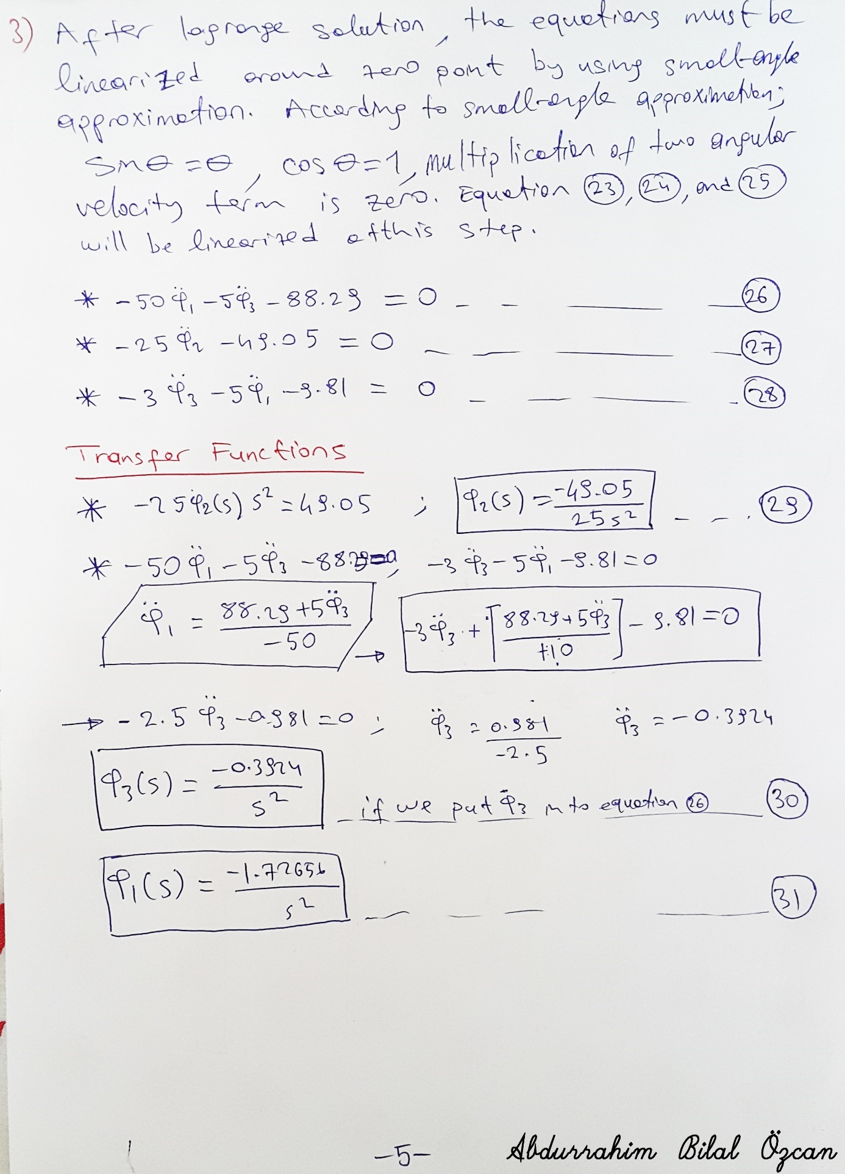

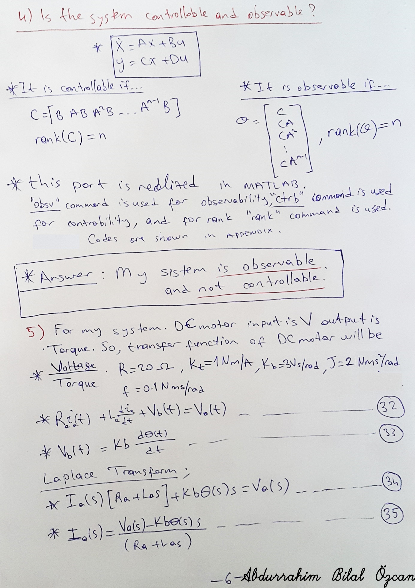

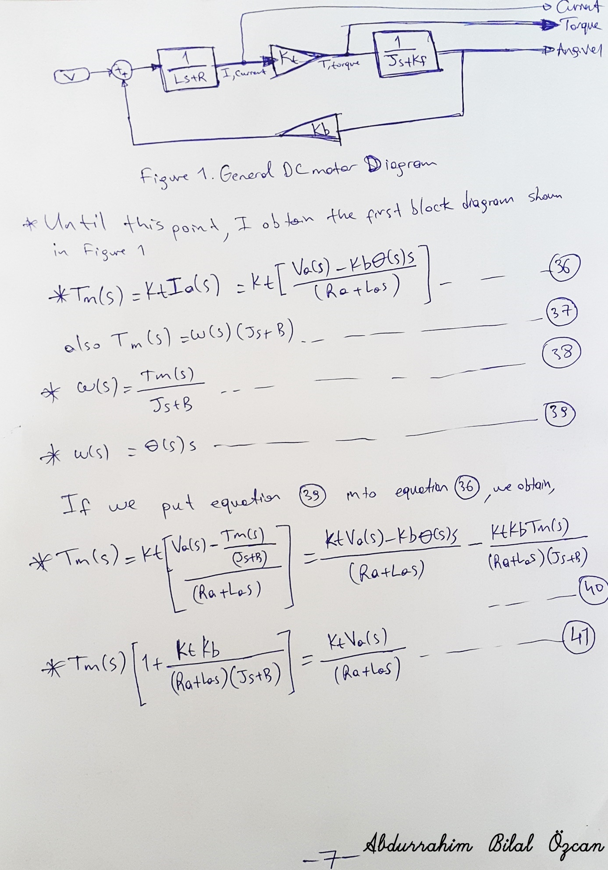

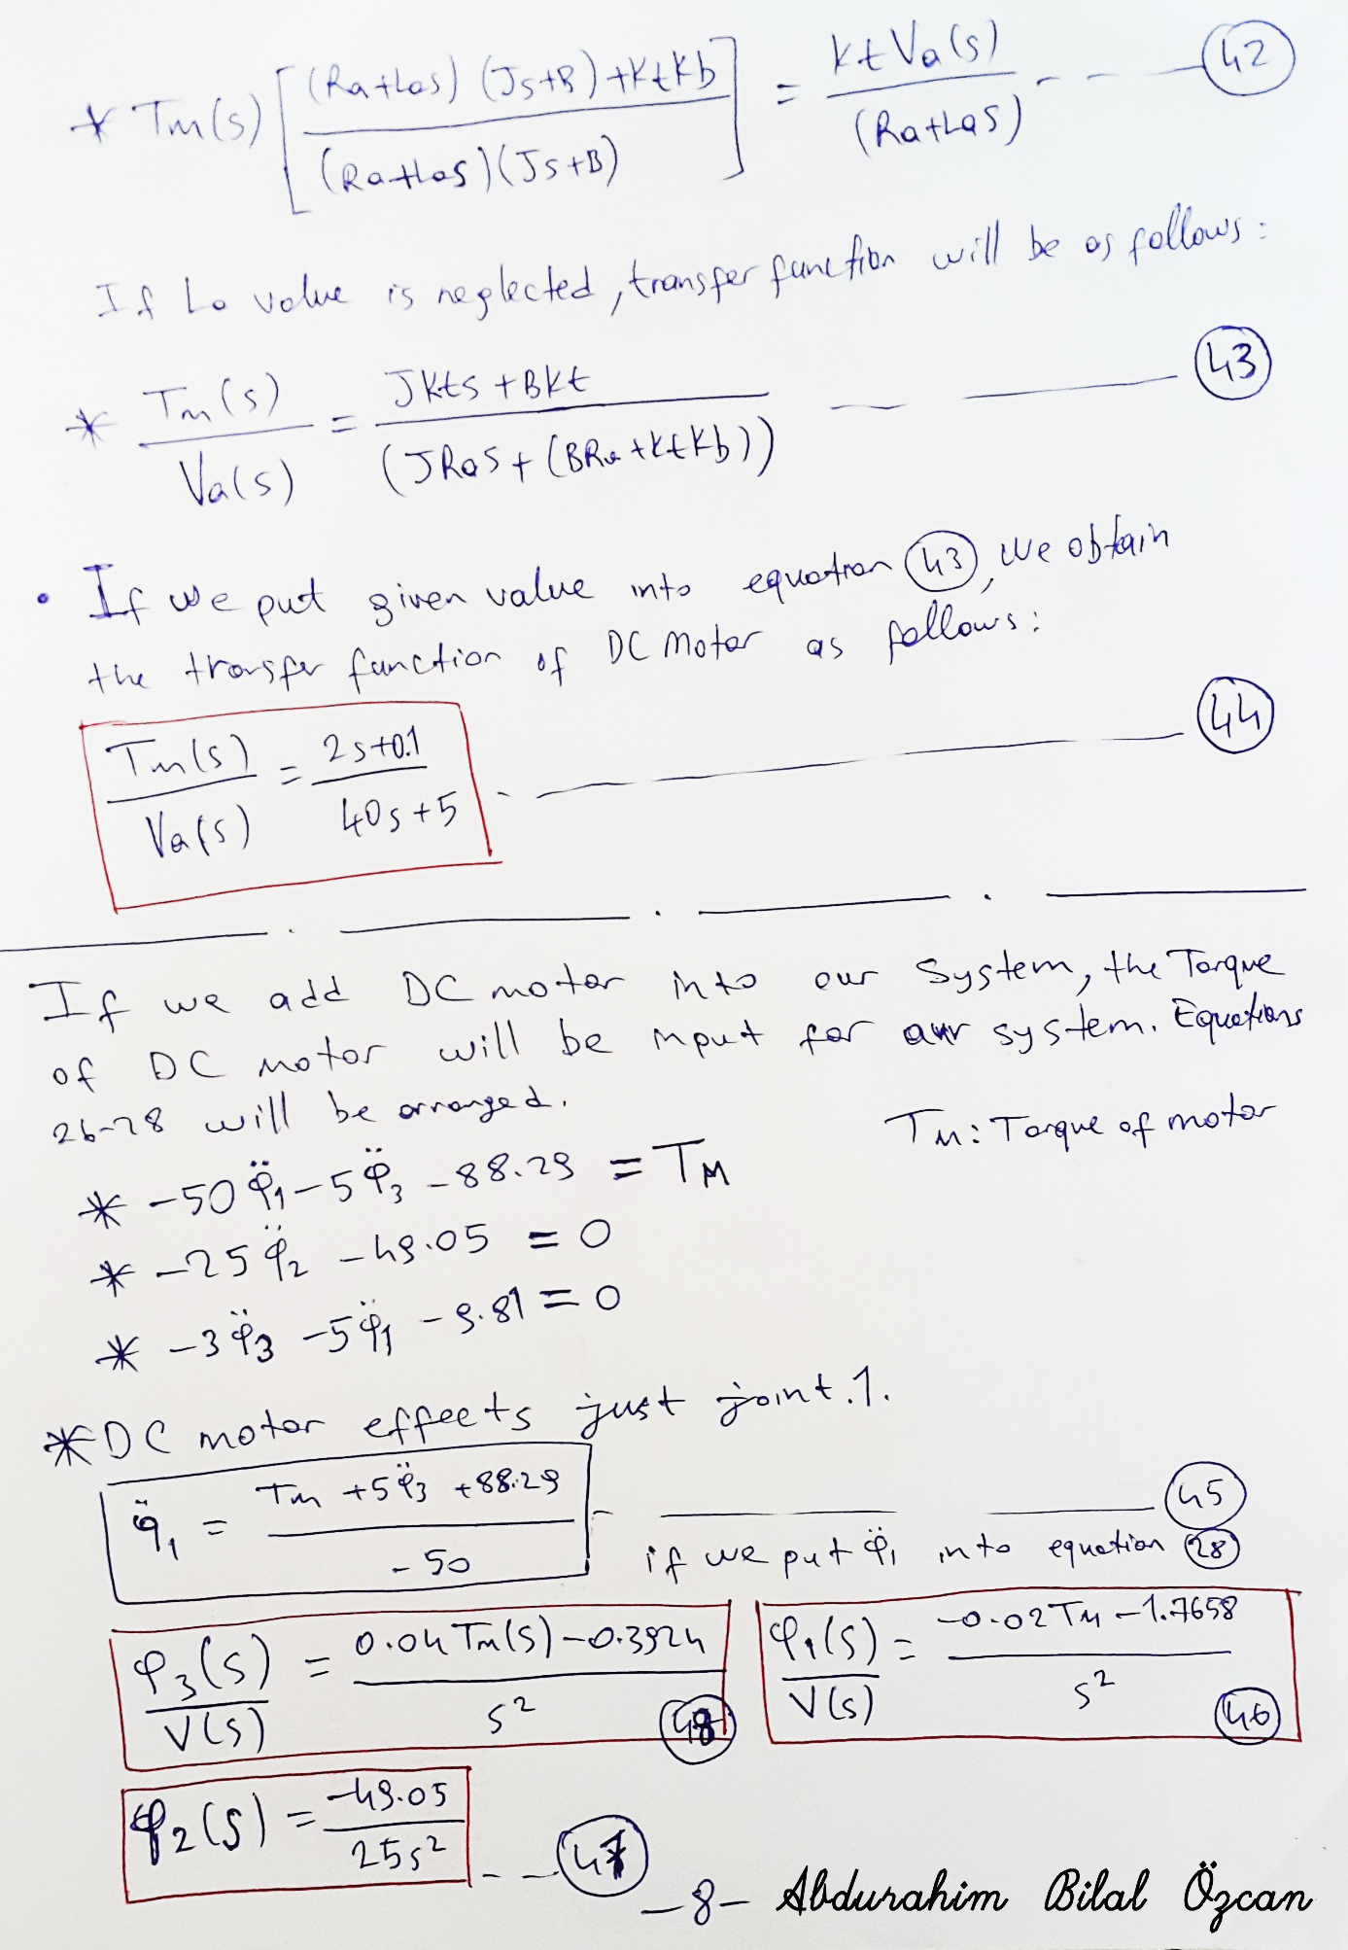

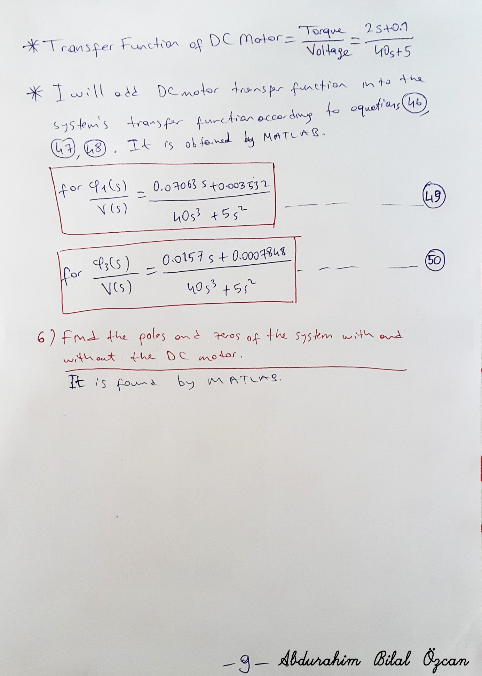

**5) Simulink Diagram of the System**

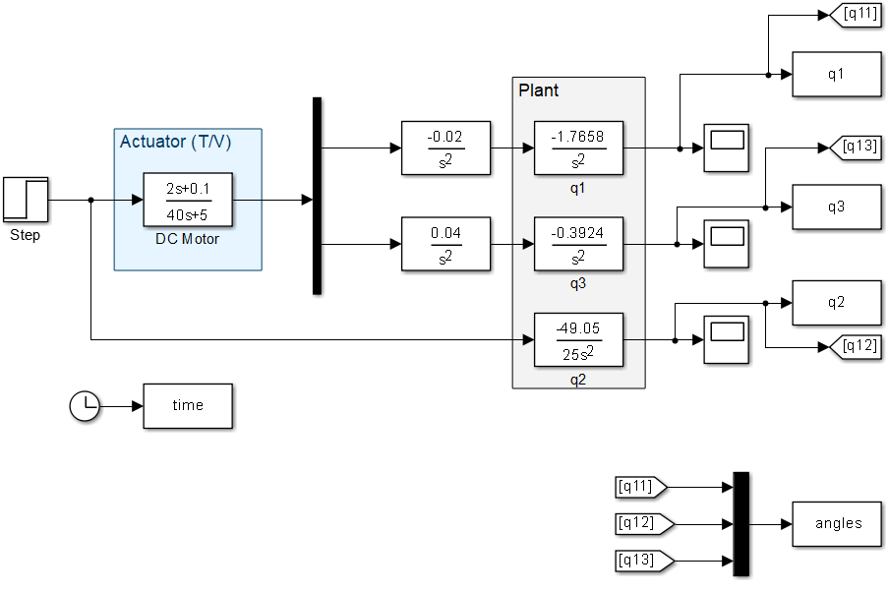

**Figure 1** Plant Model with DC Motor Model Simulink Diagram

**6) The Poles and Zeros Of The System**

Without DC Motor

For $φ_{1}$

numq1=[-1.7658];

denumq1=[1 0 0];

q1tf=tf(numq1,denumq1);

pzmap(q1tf)

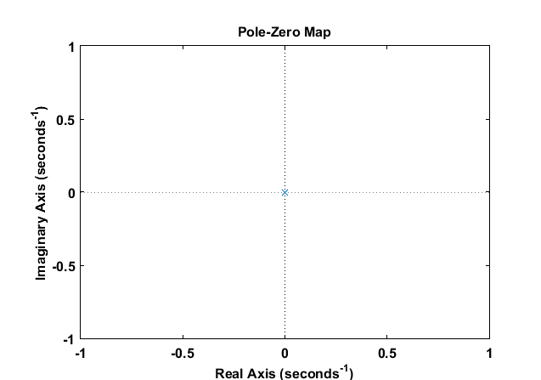

**Figure 2** Pole-Zero Map of $φ_{1}$

For $φ_{2}$

numq2=[-49.05];

denumq2=[25 0 0];

q2tf=tf(numq2,denumq2);

pzmap(q2tf)

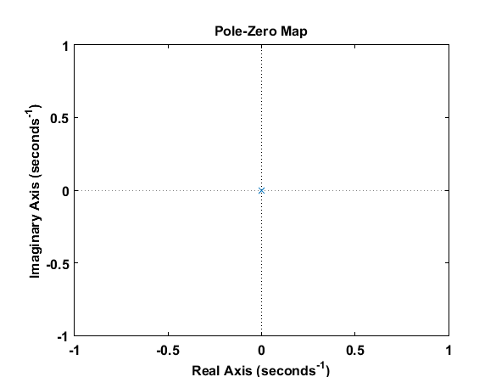

**Figure 3** Pole-Zero Map of $φ_{2}$

For $φ_{3}$

numq3=[-0.3924];

denumq3=[1 0 0];

q3tf=tf(numq3,denumq3);

pzmap(q3tf)

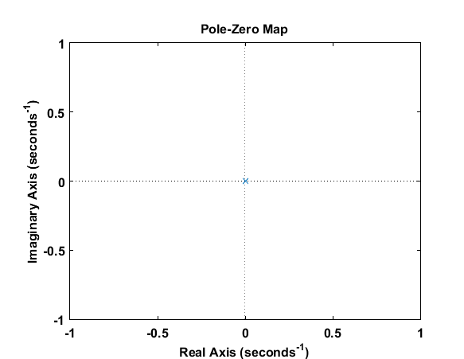

**Figure 4** Pole-Zero Map of $φ_{3}$

**With DC Motor**

For $φ_{1}$

% With DC Motor

DCnum=[2 0.1];

DCdenum=[40 5];

DCtf=tf(DCnum,DCdenum);

sysnumq1=[-1.7658];

sysdenumq1=[1 0 0];

systf=tf(sysnumq1,sysdenumq1);

Gs=series(-0.02*DCtf,systf)

pzmap(Gs)

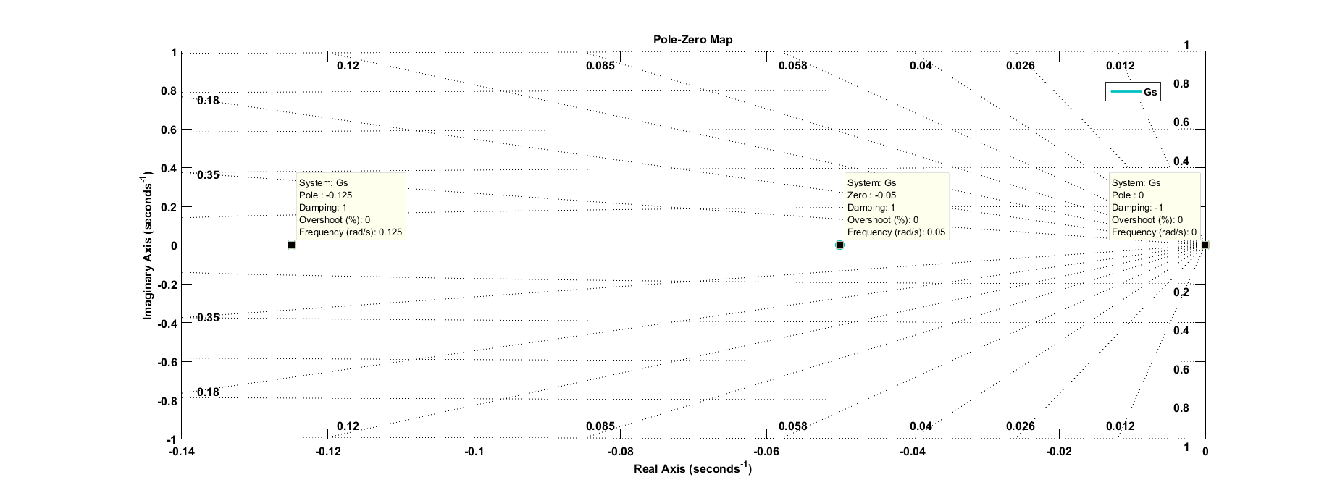

**Figure 5** Poles - Zeros of the $φ_{1}$ with DC Motor

Poles=[ 0 , 0, -0.125];

Zeros=[ -0.05 ];

**For $φ_{2}$**



**Figure 6** Pole-Zero Map of $φ_{2}$

**For $φ_{3}$**

DCnum=[2 0.1];

DCdenum=[40 5];

DCtf=tf(DCnum,DCdenum);

sysnumq2=[-0.3924];

sysdenumq2=[1 0 0];

systf=tf(sysnumq2,sysdenumq2);

Gs2=series(-0.02*DCtf,systf)

pzmap(Gs2)

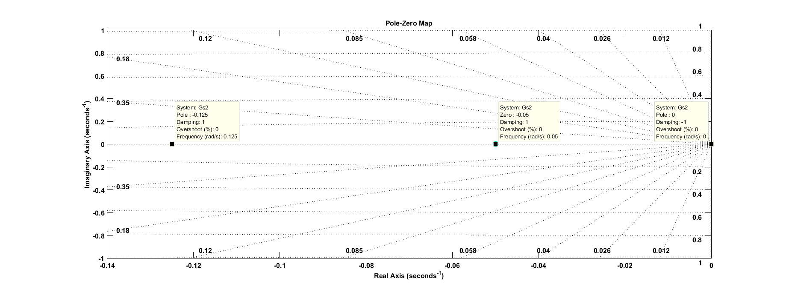

**Figure 6** Poles - Zeros of the $φ_{3}$ with DC Motor

Poles=[ 0 , 0, -0.125];

Zeros=[ -0.05 ];

**7) Plot the step response of the mechanism powered by the DC motor where the input is the voltage input to the DC motor.**

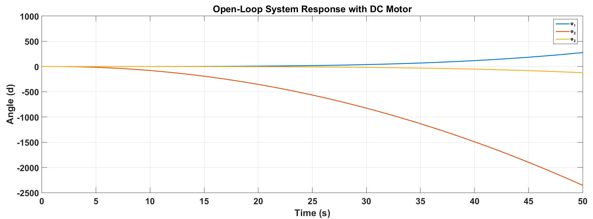

**Figure 7** System Responce of $φ_{1},φ_{2},φ_{3}$ for 50 sec.

**8) What are the rise time, settling time, percent overshoot, peak time and peak magnitude ? (namely, time domain performance measures)**

Since system goes to infinitive, I could not find time domain performance criteria.

**9) Draw the Bode plot of the system. What are the phase margin, gain margin, resonant frequencies and bandwidth of the system ? (namely, frequency domain performance measures)**

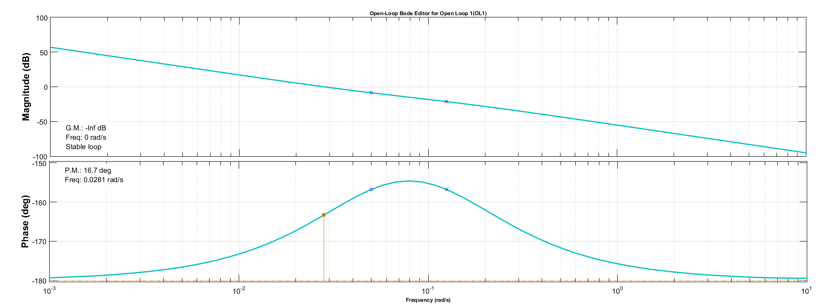

**Figure 8** Bode plot of the $φ_{1}$

[Gm,Pm,Wcg,Wcp] = margin(Gs)

Gain Margin = 0

Phase Margin = 16.6741

Wcg = 0 % Gain Crossover frequency

Wcp = 0.0281 % Phase Crossover frequency

The "bandwidth" command returns NaN for models with infinite DC gain.

**10) Design a PID for the mechanism using the Ziegler-Nichols rules and obtain the step response of the mechanism.**

**Table 1** Zeigler Nichols Method

|  |  |  |  |
| --- | --- | --- | --- |
| Control Type | Kp | Ki | Kd |
| P | 0.5Ku | - | - |
| PI | 0.45Ku | 1.2 Kp/ Tu | - |
| PID | 0.60Ku | 2 Kp/ Tu | Kp Tu/8 |

There are some basic rules of Zeigler Nichols method. The first step is choosing correct Kp which oscillate the system. By this way, we fint the systems period Tu. Then this method is calculated according to Table 1 value.

It is arranged in MATLAB Simulink PID block diagram by tuning. PID parameters Kp , Ki, Kd found as follows:

Kp=350,7

Ki=32.6

Kd=893.2

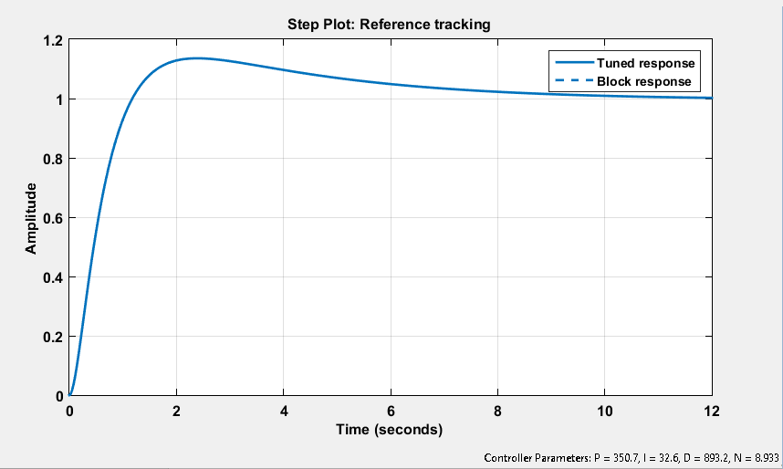

**Figure 9** Step Response of the Mechanism

**11) Draw the block diagram of the system. Find the corresponding transfer function of the mechanism controlled by the PID controller.**

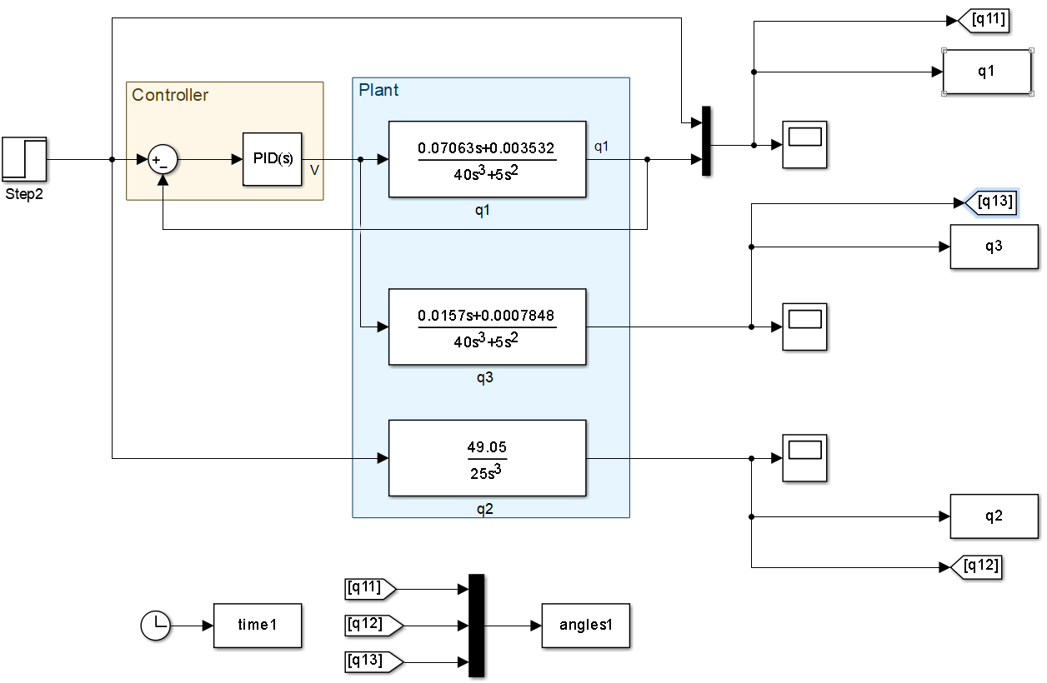

**Figure 10** Block Diagram of the Mechanism Controlled by the PID Controller

**12) What are the poles and zeros of the closed-loop system ? Draw the step response of the system.**

For $φ_{1}$

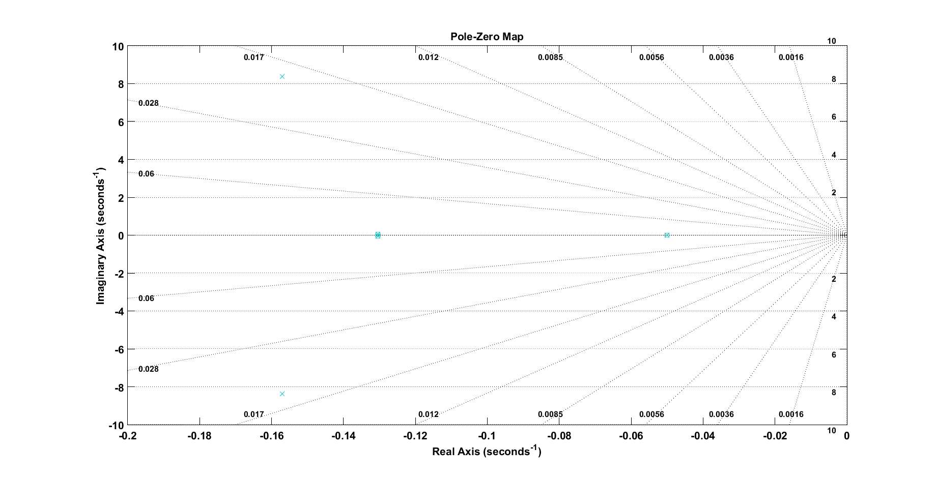

**Figure 11** Poles-Zeros Map of Closed-Loop System

Poles= [ -0.1570 + 8.3840i, -0.1570 - 8.3840i, -0.1305 + 0.0586i, -0.1305 - 0.0586i, -0.0500 + 0.0000i]

Zeros= [ -0.1304 + 0.0586i, -0.1304 - 0.0586i, -0.0500 + 0.0000i]

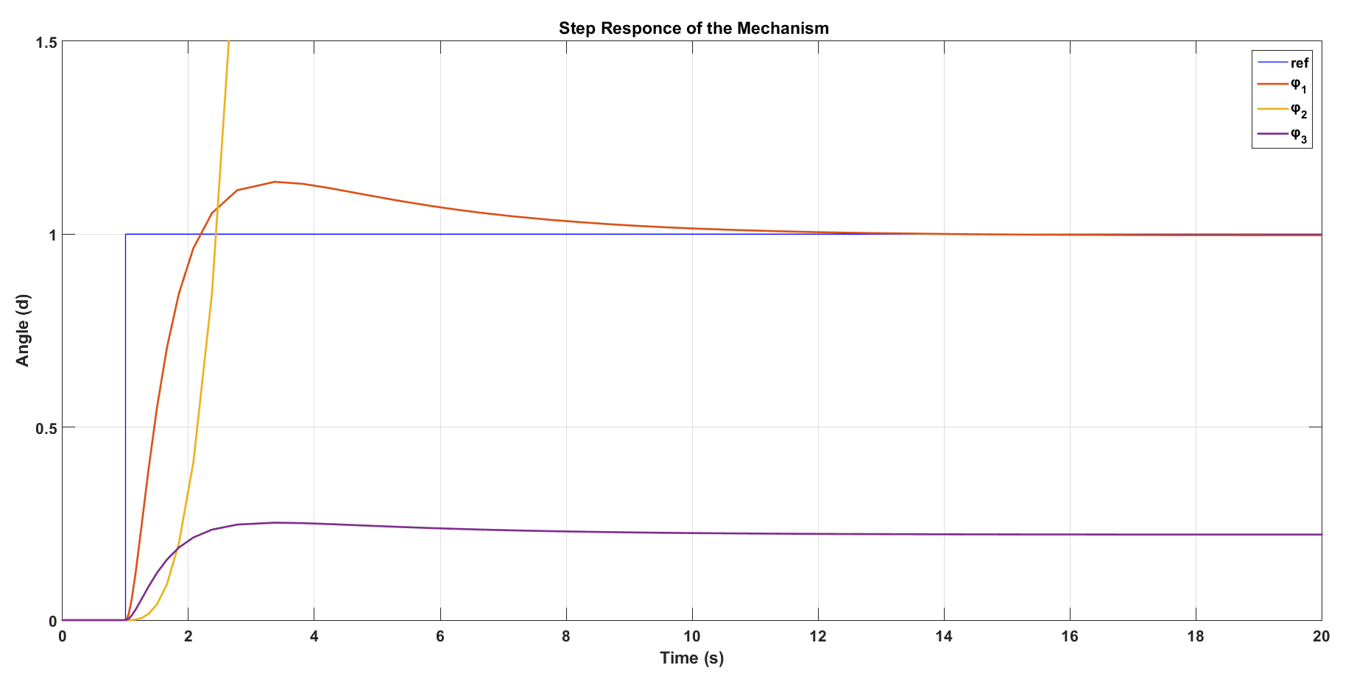

**Figure 12** Step Response of the Mechanism

**13) What is the system type (0, 1, or 2) ? What are the frequency and time domain performance measures (as listed in parts 8 and 9) ?**

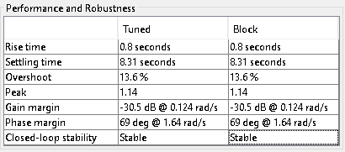

**Figure 13** Time Domain and Frequency Domain Response of the System

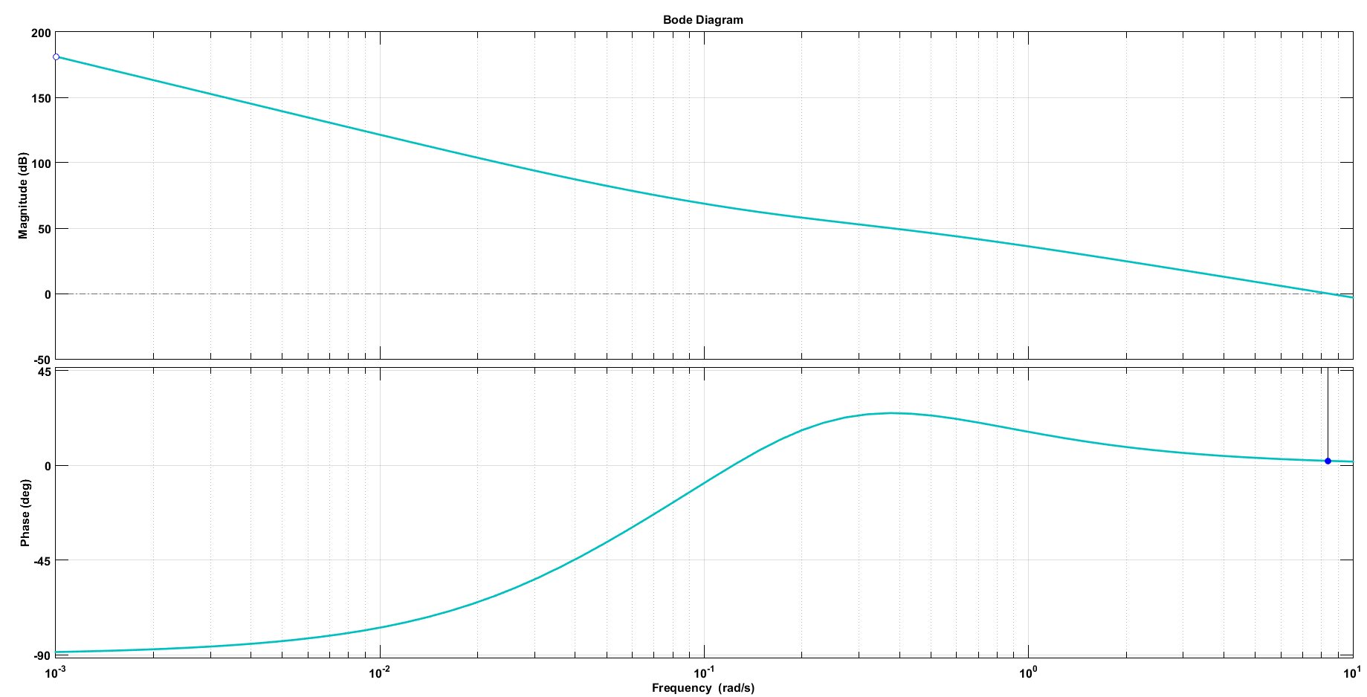

**Figure 14** Bode Diagram of the System

**15) Obtain the step response of the discrete-time implementation of the PID controller using a Zero-Order-Hold circuit and the sampling time of T=1, 0.1, and 0.01 second.**

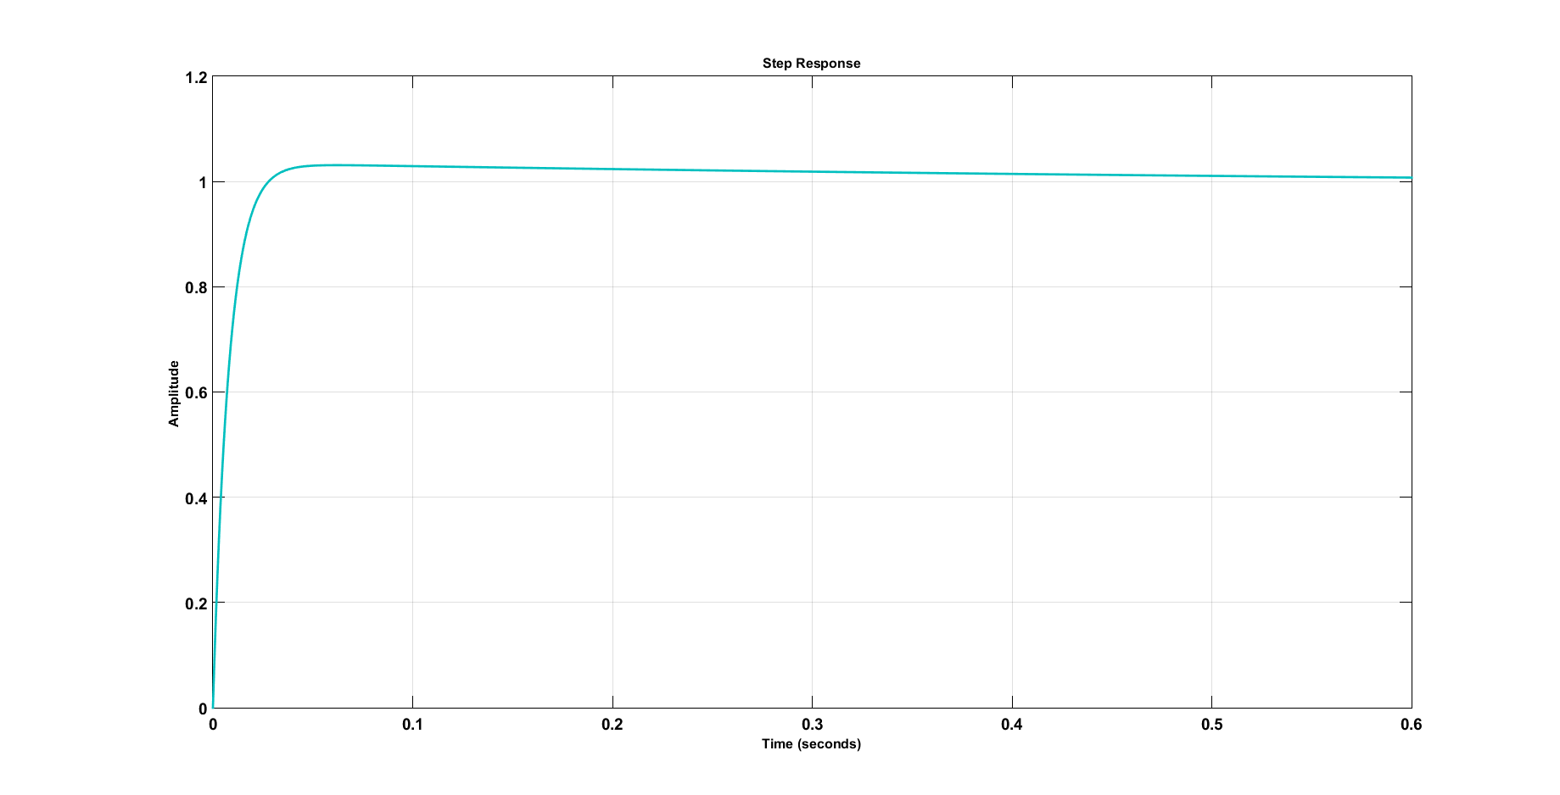

**Figure 15** Step Response of the Discrete-Time Implementation of the PID Controller for T=1

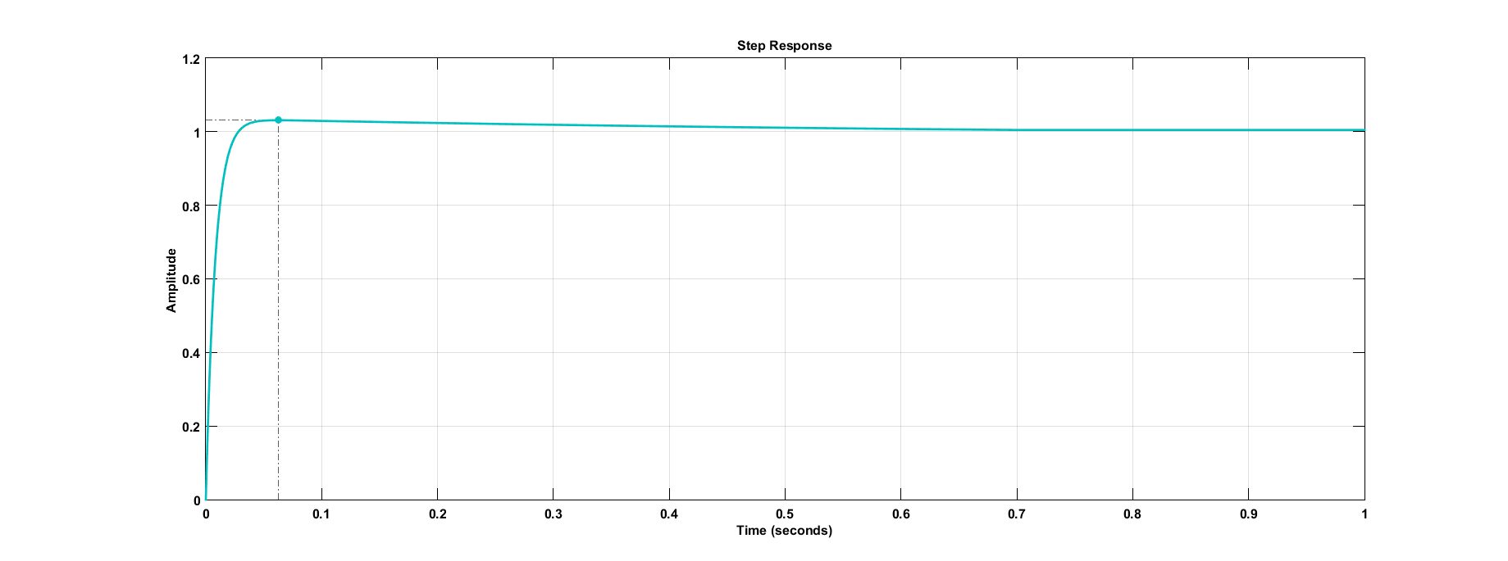

**Figure 16** Step Response of the Discrete-Time Implementation of the PID Controller for T=0.1

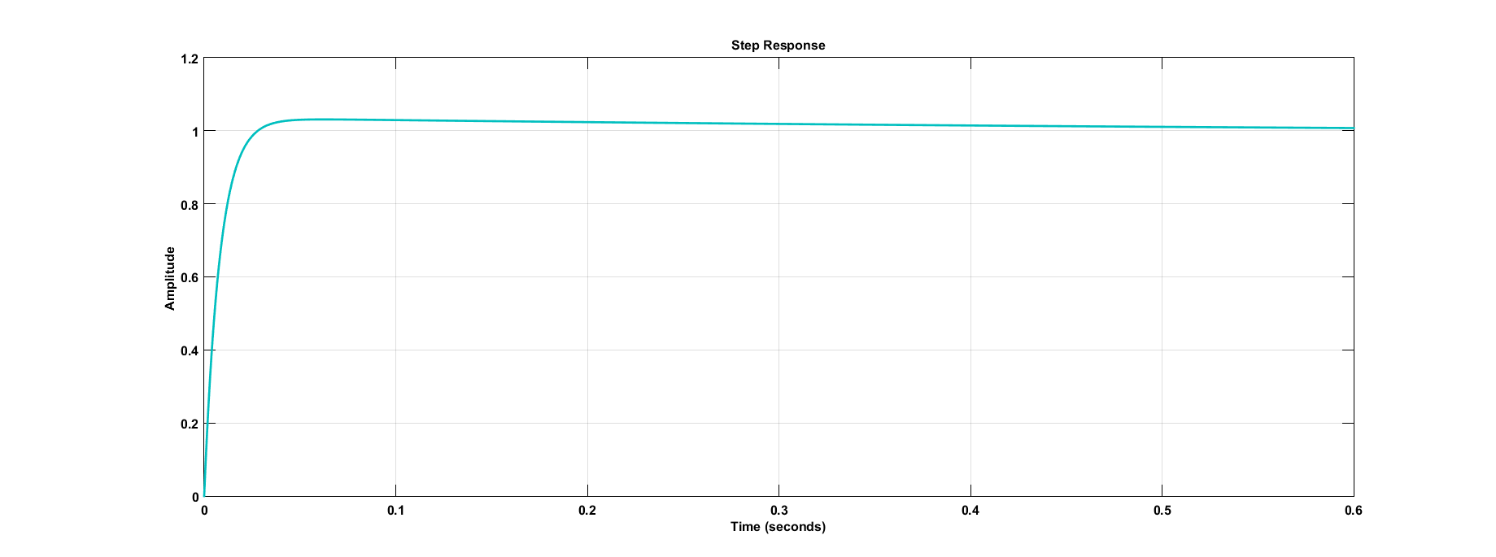

**Figure 17** Step Response of the Discrete-Time Implementation of the PID Controller for T=0.01

%% Discrete Control Codes written in MATLAB

T = 1; %Sampling Time

d_sys = c2d(sys_cl,T,'zoh'); % Converts continuous-time dynamic system to discrete time

% impulse(d_sys);

% step(d_sys)

% Discrete-Time State Space Model which is obtained by "c2d" command

a =[ 0.9999 0 -0;0.0005 1 0;0 0.0005 1];

b = [ 0.0005;0;0];

c = [0 -0.0883 -0.0044];

d=0;

Q=[1 0 0;0 1 0;0 0 1];

R=[1];

K=lqr(a,b,Q,R); % K = 11.5605 18.2677 10.0000

sys_discrete= ss(a-b*K, b, c, d);

step(sys_discrete) %Closed loop

TfLQRDiscrete=K*inv(s*eye(3)-a)*b; % Transfer Function is obtained

Kp=21.1;

Ki=26;

Kd=0;

H=1;

Gc=pid(Kp,Ki,Kd);

DscConPID=feedback(Gc*TfLQRDiscrete,H);

step(DscConPID);

**16-17-18) Design an LQR controller for the continuous time mechanism model powered by a DC motor using Matlab. The goal should be better percent overshoot and rise time than those of the PID. Then, find the corresponding transfer function of the mechanism controlled by the LQR state-feedback.**

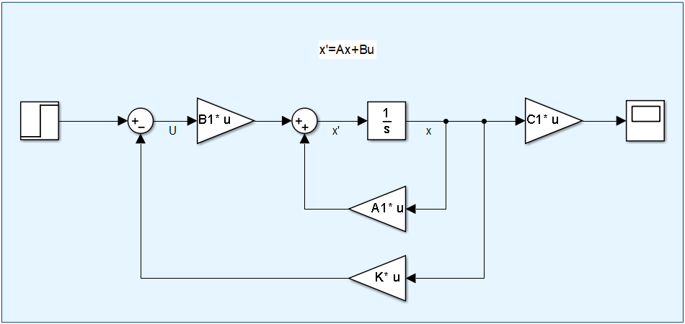

**Figure 18** LQR Controller Design of the System

For Q=[1 0 0;0 1;0 0 1]; R=[1]; K =[ 2.2931 2.4158 1.0000 ]

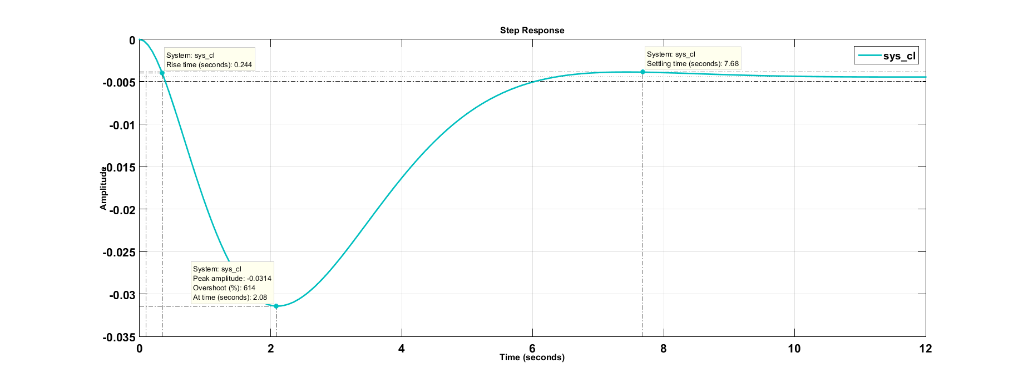

**Figure 19** LQR Response of the System For Q=eye(3) R=1

For Q=[100 0 0;0 100 0;0 0 100]; R=[1]; K =[ 11.5605 18.2677 10.0000 ]

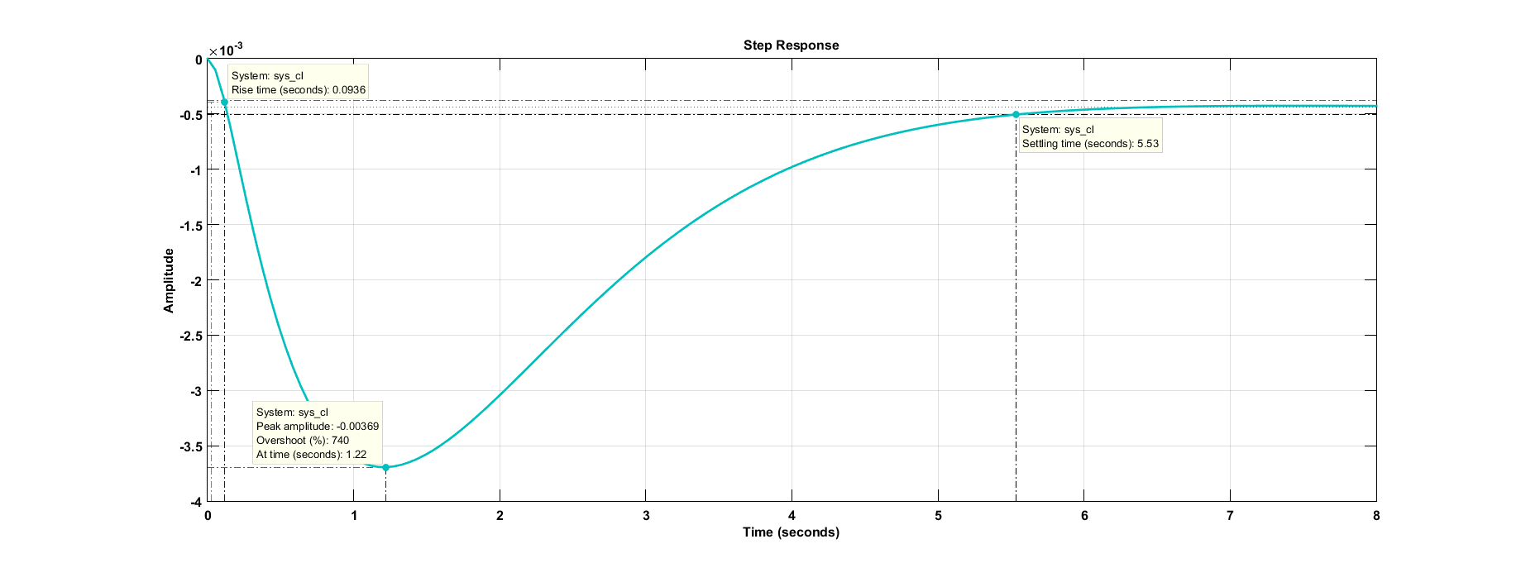

**Figure 20** LQR Response of the System for Q=100*eye(3) R=1

For Q=[1000 0 0;0 1000 0;0 0 1000]; R=[1]; K =[ 33.2145 55.7546 31.6228]

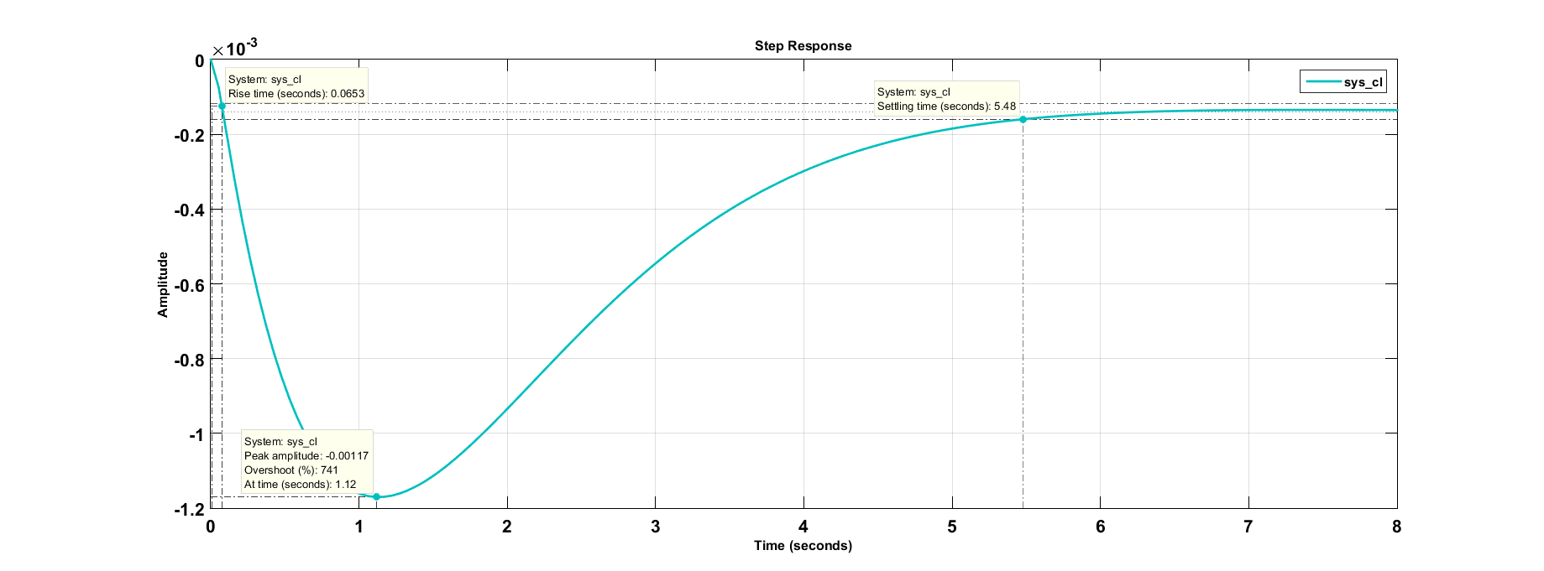

**Figure 21** LQR Response of the System For Q=1000*eye(3) R=1

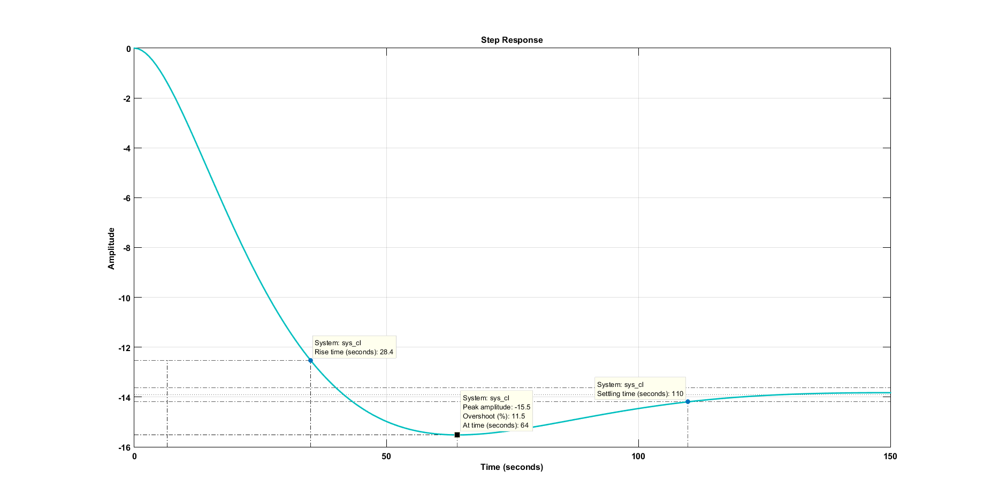

**Figure 22** LQR Response of the System for Q= Q=10^-7*[100 0 0;0 0.001 0;0 0 1] R=1

**Table 2** LQR Responses List of the

|  |  |  |  |
| --- | --- | --- | --- |
| Q and R values | Rise Time (tr) | Overshoot(%) | Settling Time (ts) |
| Q=eye(3) R=1 | 0.244s. | 614 | 7.68 s. |
| Q=100*eye(3) R=1 | 0.0939s. | 740 | 5.53 s |
| Q=1000*eye(3) R=1 | 0.0653 | 741 | 5.48 |
| Q=10^-7*[100 0 0;0 0.001 0;0 0 1];  R=1 | 28.4 | 11.5 | 110 |

For the last experiment, I’ve obtained the best overshoot value, especially if I compare PID controller overshoot shown in Figure 13, among LQR values. However, Rise time and settling time have increased. For my system, dump truck, the last experiment may be beneficial. Let me think this vehicle is dustcart, overshoot is very critical criteria for environment and people living around this environment.

For the best Q and R values, global search algorithm should be used.

Then,

In order to obtain corresponding transfer function of the mechanism controlled by the LQR state-feedback, I use this code in MATLAB:

TfLQR=K*inv(s*eye(3)-A)*B;

I obtain this transfer function:

$\frac{0.06946 s^{5}+0.02846 s^{4}+0.004174s^{3}+0.0002523 s^{2}}{s^{6}+0.375 s^{5}+{0.04688s}^{4}+{0.001953s}^{3}}$

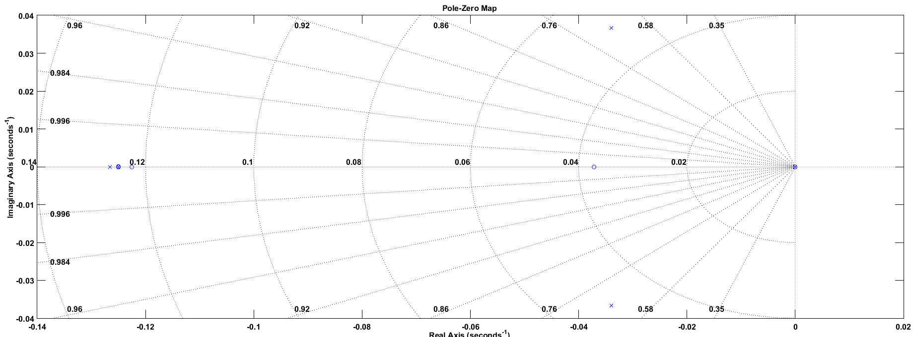

**Figure 23** Poles- Zeros Map of LQR Controlled System

Poles= [ -0.1250 + 0.0000i, -0.1250 - 0.0000i, -0.1250 + 0.0000i, 0.0000 + 0.0000i, -0.0000 + 0.0000i, -0.0000 + 0.0000i];

Zeros=[-0.1250 + 0.0000i, -0.1250 - 0.0000i, -0.1225 + 0.0000i, -0.0372 + 0.0000i, 0.0000 + 0.0000i];

**APPENDIX**

MATLAB Codes

%% MKM506E | Modelling and Control of Mechanical Systems

%% Lecturer: Prof.Dr.Ata Muğan

%% Abdurrahim Bilal Özcan | 514191026

%%

clc,clear all

num=-0.3924;

denum=[1 0 0];

[A,B,C,D]=tf2ss(num,denum)

%% State-Space Model

A=[0 0 1;0 0 0;0 0 0];

B=[0;0;1];

C=[0 0 -1.72656;0 0 -0.3924;0 0 -1.96];

D=[0;0;0];

%

% [NUM,DENUM]=ss2tf(A,B,C,D)

%% Transfer Function

s=tf('s');

TrafFnc=C*inv(eye(3)*s^2-A)*B+D;

%% Controllability and Observability

Qb=obsv(A,C);

if(rank(Qb)== rank(A))

disp('Given System is Observable')

else

disp('Given System is not Observable')

end

Cr=ctrb(A,B);

if(rank(Cr)== rank(A))

disp('Given System is Controllable')

else

disp('Given System is not Controllable')

end

%% Poles ans zeros of the system with without DC Motor

% With DC Motor

%For q_1

DCnum=[2 0.1];

DCdenum=[40 5];

DCtf=tf(DCnum,DCdenum);

sysnumq1=[-1.7658];

sysdenumq1=[1 0 0];

systf=tf(sysnumq1,sysdenumq1);

Gs=series(-0.02*DCtf,systf);

controlSystemDesigner('bode',Gs); %Bode Diagram for q_1

margin(Gs);

[Gm,Pm,Wcg,Wcp] = margin(Gs); % Gain and phase margins and crossover frequencies

fb = bandwidth(Gs)

controlSystemDesigner('bode',Gs); %Bode Diagram for q_1

pzmap(Gs)

%For q_3

sysnumq2=[-0.3924];

sysdenumq2=[1 0 0];

systf=tf(sysnumq2,sysdenumq2);

Gs2=series(-0.02*DCtf,systf)

pzmap(Gs2)

%% Without DC Motor

numq1=[-1.7658];

denumq1=[1 0 0];

q1tf=tf(numq1,denumq1);

pzmap(q1tf)

numq3=[-0.3924];

denumq3=[1 0 0];

q3tf=tf(numq3,denumq3);

pzmap(q3tf)

numq2=[-49.05];

denumq2=[25 0 0];

q2tf=tf(numq2,denumq2);

pzmap(q2tf)

%% Ziegler - Nichols Method

KU=180; %From Simulation

TU=3.9; %From Simulation

[KP, KI, KD] = ZieglerNichols(KU,TU,'NoOvershoot')

%% Poles-Zeros Map of Closed-Loop System

% For q1

DCnum=[2 0.1];

DCdenum=[40 5];

DCtf=tf(DCnum,DCdenum);

sysnumq1=[-1.7658];

sysdenumq1=[1 0 0];

systf=tf(sysnumq1,sysdenumq1);

C=pid(350.7,32.6,893,2);

Control=series(DCtf,systf);

last=feedback(C*Control,-1); %feedback

controlSystemDesigner('bode',last); %Bode Diagram for q_1

% For q3

DCnum=[2 0.1];

DCdenum=[40 5];

DCtf=tf(DCnum,DCdenum);

numq3=[-0.3924];

denumq3=[1 0 0];

q3tf=tf(numq3,denumq3);

C=pid(350.7,32.6,893,2);

Control=series(DCtf,systf);

last=feedback(C*Control,-1); %feedbask

controlSystemDesigner('bode',last); %Bode Diagram for q_1

%% LQR Controller Design

num=[-3.532 -0.1766];

denum=[40 5 0 0];

[A,B,C,D]=tf2ss(num,denum); % I pass state-space form from transfer function

A1=[-0.125 0 0;1 0 0;0 1 0];

B1=[1;0;0];

C1=[0 -0.0883 -0.0044];

D1=0

Q=10^-7*[100 0 0;0 0.001 0;0 0 1];

R=[1];

K=lqr(A1,B1,Q,R) % K = 11.5605 18.2677 10.0000

sys_cl = ss(A1-B1*K, B1, C1, D1);

step(sys_cl) %Closed loop

%% Poles and Zeros of the LQR Controlled System

TfLQR=K*inv(s*eye(3)-A1)*B1

pole(TfLQR)

zero(TfLQR)

controlSystemDesigner('bode',TfLQR);